Enzyme Practice Sheet Key

- (4 points) Label the boxes as the: enzyme catalyzed reaction or non-enzyme catalyzed reaction. Explain what is occurring and the effect on the reaction

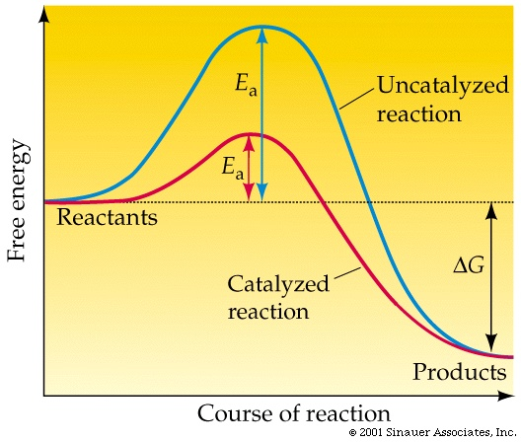

A catalyst speeds up a chemical reaction by providing an alternate pathway for the reaction that has a lower activation energy than the uncatalyzed reaction.

- Classify the enzymes that catalyze the reactions below as being one of the following (Oxidoreductase, hydrolase, isomerase, ligase, lyase, transferase,)
  - oxidaze

  - isomerase

  - hydrolase (specifically beta lactamase)

- Differentiate between lock and key model and induced fit model of enzyme action?
Induced fit: is a more recent theory which suggests that the substrate attaches to the enzyme in a relatively accurate fit, then the enzyme molds around it, then continues the chemically complex reaction.
Lock and Key Mechanism: As obvious as the name states, the lock and key model is simply the substrate fitting acutely into the enzyme with no adjustments required to the enzyme.

- Draw a cartoon diagram to illustrate an enzyme that binds to a substrate (represented by a triangle) only in the presence of an activating factor (represented by a circle). Your diagram should have an illustration for the enzyme alone, the substrate NOT binding to the enzyme alone, the enzyme with the activating factor, and the enzyme, activating factor, and substrate combined.

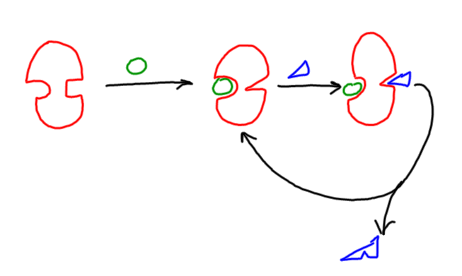
- If an enzyme has a maximum activity at 40°C, would the activity be most reduced at 30°C or at 50°C? Explain.

At lower temperatures, reaction rates are slowed because there is not enough energy available to surpass the activation energy. At higher temperatures, the enzyme is denatured and completely loses activity. Thus, activity falls off more quickly above the ideal temperature than below it. The activity would be more reduced at 50°C.

- Explain how different factors can affect enzyme reaction rate (pH, temperature, and substrate)

pH: there is an optimum pH at which the enzyme can maximize activity. above or below this pH the conditions are too basic or acidic for the enzyme to fold properly and worse, the enzyme can be hydrolyzed (denatured) much faster by conditions too far from the optimum

temperature: There is also an optimum temperature for enzyme operation. at lower than optimum temperatures, the activity can be sped up because increased heat (higher temperature) will speed up any reaction, including enzymatic ones). above the optimum temperature, enzyme denaturation, thus inactivation, occurs at a higher rate. This will slow down reaction rate

substrate concentration: assuming the presence of enzyme, reaction rate can be increased by adding more substrate, up to a point. that point is called the maximum velocity. maximum velocity is the fastest an enzyme can operate, regardless of how much substrate is present. you could liken it to a factory, where, if there is plenty of raw material available, you could have your workers do overtime, but eventually, the capacity of your assembly lines is maxed out and addtional workers and raw material will not speed up your production any. as one approaches maximum velocity, the curve is almost asymptotic. that is, each additional increase in substrate produces a smaller increase in reaction rate (there is a diminishing rate of return).

- Why does increasing the substrate concentration reverse the inhibition by a competitive inhibitor?

A competitive inhibitor works by binding to the active site of the enzyme, so that the substrate can’t bind. However, the inhibitor comes on and off the enzyme, and when it’s off, the substrate can bind. So, if the substrate concentration is high relative to the inhibitor concentration, then substrate can out-compete the inhibitor for binding.

- Describe the difference between reversible and irreversible inhibition, and between competitive and non-competitive inhibition

reversible inhibition can be undone, irreversible permanently takes out the enzyme. In competitive inhibition, both the substrate and the inhibitor (molecule that inactivates the enzyme, in this case, temporarily) want to sit in the active site. who gets there can depend on the concentration of the inhibitor and the substrate. In non-competitive inhibition, the inhibitor sits on the enzyme someplace other than the active site, deactivating the enzyme (until the inhibitor leaves). In non-competitive inhibition, the relative concentrations of substrate and inhibitor aren’t as important since the two don’t contend for the enzyme’s attention – the inhibitor can waltz onto the enzyme at any time since the substrate can only sit on the active site and cannot prevent the non-competitive inhibitor from sitting somewhere else.

- Illustrate and label the interactions between this hypothetical model of a substrate molecule bound in the active site of an enzyme

- Enzyme terminology fill in the correct word for the definition

lock and key theory: active site in an enzyme has a fixed, rigid shape. Only substrates with a complementary geometry can fit.
induced-fit model: active site in an enzyme can undergo small changes in shape in order to accommodate a substrate

Reversible inhibitor: goes on and off, allowing the enzyme to regain activity when the inhibitor leaves

Irreversible inhibitor: destroys enzyme activity, usually by bonding with side-chain groups in the active site
competitive inhibition: competition between an inhibitor and substrate of similar structure for the active site of the enzyme
noncompetitive inhibition: inhibitor binds to enzyme at a location other than the active site and deactivates the enzyme.
Cofactors are inorganic species or at least non-protein compounds that aid enzyme function by increasing the rate of catalysis.

Coenzymes are non-protein organic molecules that bind loosely to an enzyme that is required for a protein's biological activity to happen.

Substrate - the compound on which the enzyme works

Active site - the specific portion of the enzyme to which the substrate binds during reaction.

Activation - any process that makes an inactive enzyme active.

Zymogens - Inactive form of an enzyme.

